



Design a website as the following requirements:

**Requirements**:

Create a folder named Myweb to save website resources. Create images and ‘styles folder are sub folder of Myweb to store image and style for website. [1 mark]

**Homepage**

* Use Unicode font.
* Set up a link from "Contact us" (in Footer) to "Contact.html" page.
* Form: Subscribe field is required

***More details:***

* 1. Create correct Layout (4 mark)
  2. Header is fixed top (1 marks)
  3. Fill the content for this page (2 marks)
  4. Create menu and link correct contact page (1 marks)
  5. Set correct title and meta tag (1 mark)
  6. Validate correct input in from (1 mark)

**Contact Page**

* Use Unicode font.
* Set up a link from "Homepage" to "index.html" page.
* Forms

Check Validate Form:

+Name: Require, max length: 50 characters

+Email: must to contain @ character

+Message: only resize horizontally

***More details:***

* 1. Create Layout and form (3 marks)
  2. Set up a link from Logo (in Header) and “Home” (in Breadcrumb) to "index.html" page (1 mark)
  3. Validate correct input in form (2 mark)

**Non-function requirements**

* Setup home and contact page can responsive on mobile (<576px), tablet(577-991 px) and desktop (>991px) size. (3 mark).

Homepage (**index.htm**)

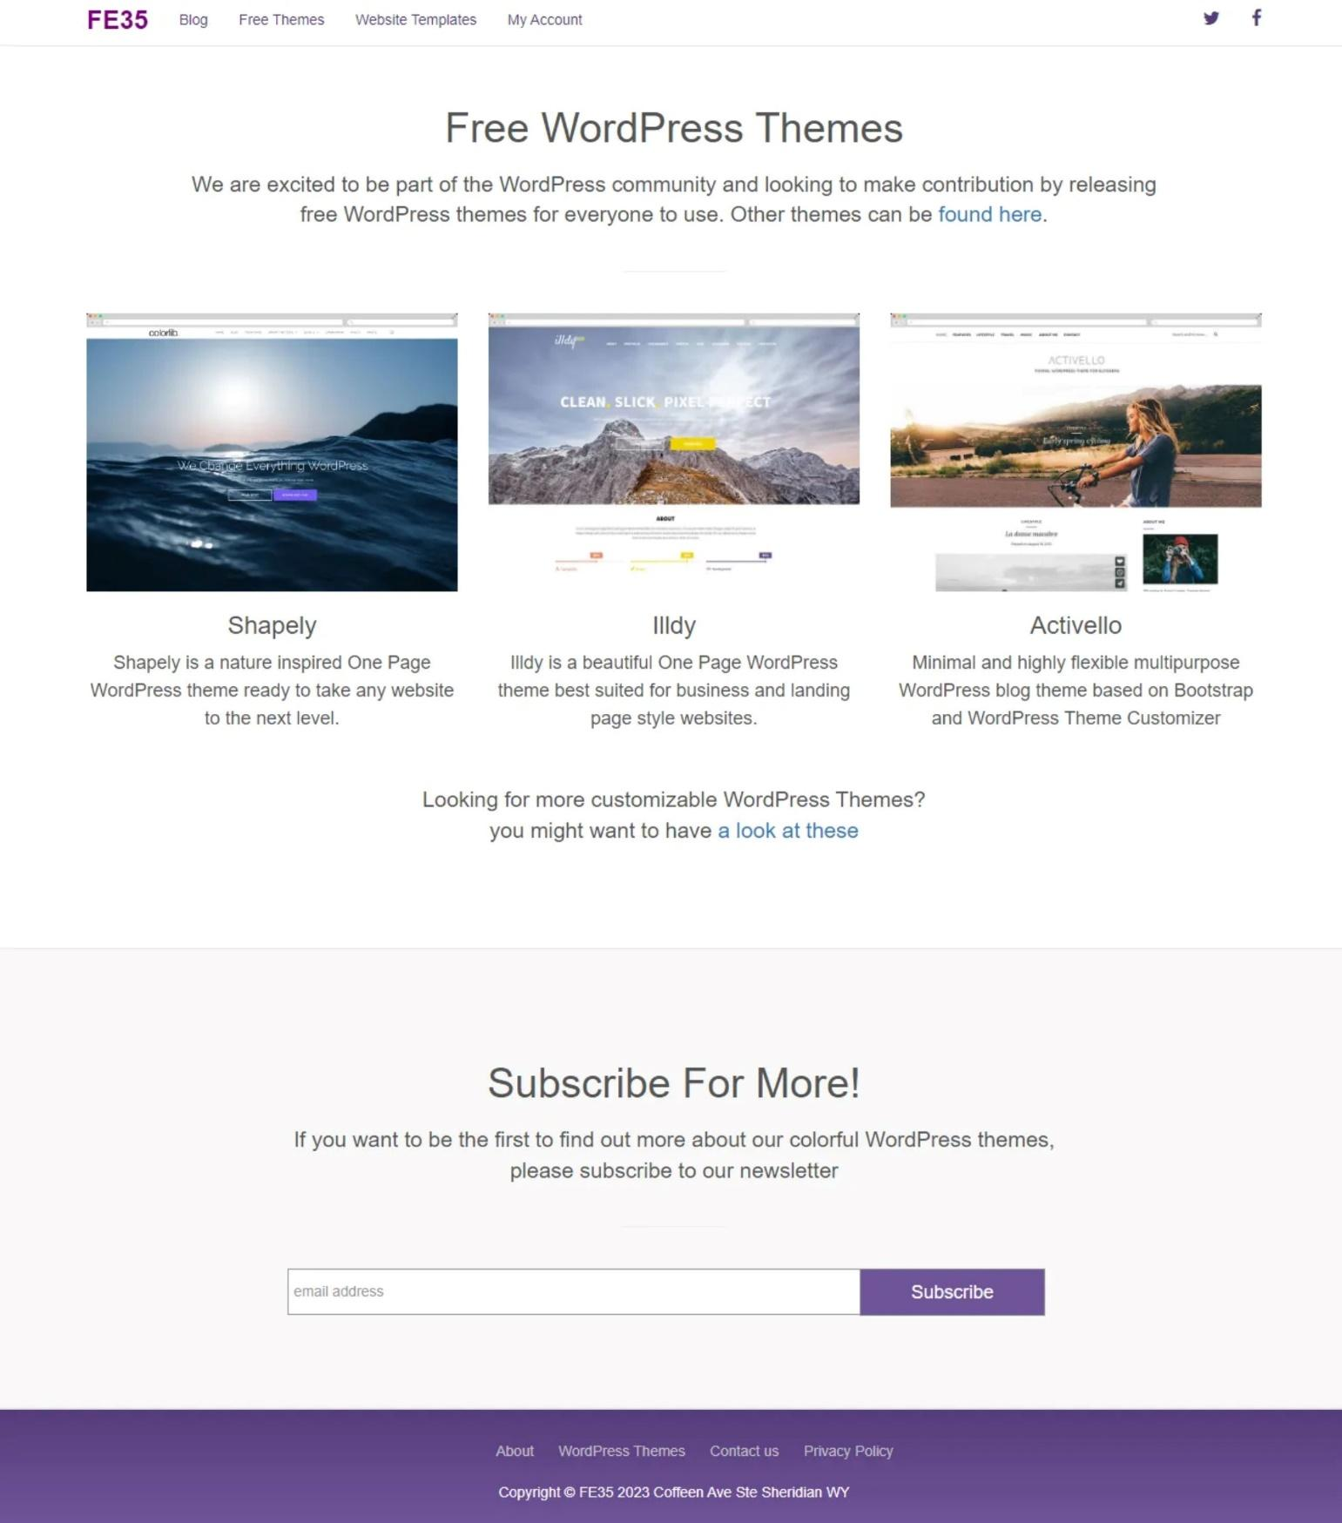

**Contact.html**

